Feature Importance and Hyperparameter Tuning on Raisin Morphometrics

Problem Statement
A 900-row image card records seven size and shape measurements on two raisin varieties (Class 0/1, 450 each). The teaching task is to (1) say which measurements actually separate the classes and (2) choose tree depth / split minimum and logistic penalty / C without peeking at the hold-out fold. A default deep tree overfits; an un-tuned C is a guess. Stakeholders also need a sentence they can use, not a 9-cell CV table.

Solution Strategy
Freeze train_test_split(..., random_state=19) → 675 / 225. Rank features three ways (single-tree Gini, forest-averaged Gini, permutation drop on the test fold). Exhaust the published 3×3 DecisionTree grid {max_depth: 3,5,7} × {min_samples_split: 2,3,4} with GridSearchCV (5-fold). Sample eight (penalty, C) pairs for LogisticRegression(solver='liblinear') with RandomizedSearchCV. Quote hold-out accuracy, not best_score_. Stress-test n_iter, train n, and label noise.

Solution
Setting | Winner | CV acc | Test acc
DT default (untuned) | full depth | — | 0.849
DT GridSearchCV 3×3 | depth=5, min_split=2* | 0.867 | 0.818
LR default liblinear | C=1, L2 | — | 0.880
LR RandomizedSearchCV n=8 | L2, C≈9.8 | 0.876 | 0.880
Scaled L1 pipeline grid | C=1, L1 | 0.881 | 0.867
*Codecademy's published run (no random_state on the tree) ties the same depth-5 row at min_samples_split=3, test ≈ 0.813. The depth-5 / depth-7 gap is the result that survives the seed.
Perimeter dominates every importance method. Single-tree Gini puts 0.59 on Perimeter; the forest spreads credit across the size block (Perimeter 0.25, MajorAxisLength 0.22, ConvexArea 0.16, Area 0.15); permutation on the hold-out fold collapses back onto Perimeter (Δacc ≈ 0.15) and the rest are noise. Scaled L1 zeros Area, MajorAxisLength and ConvexArea and keeps a large positive Perimeter coefficient.
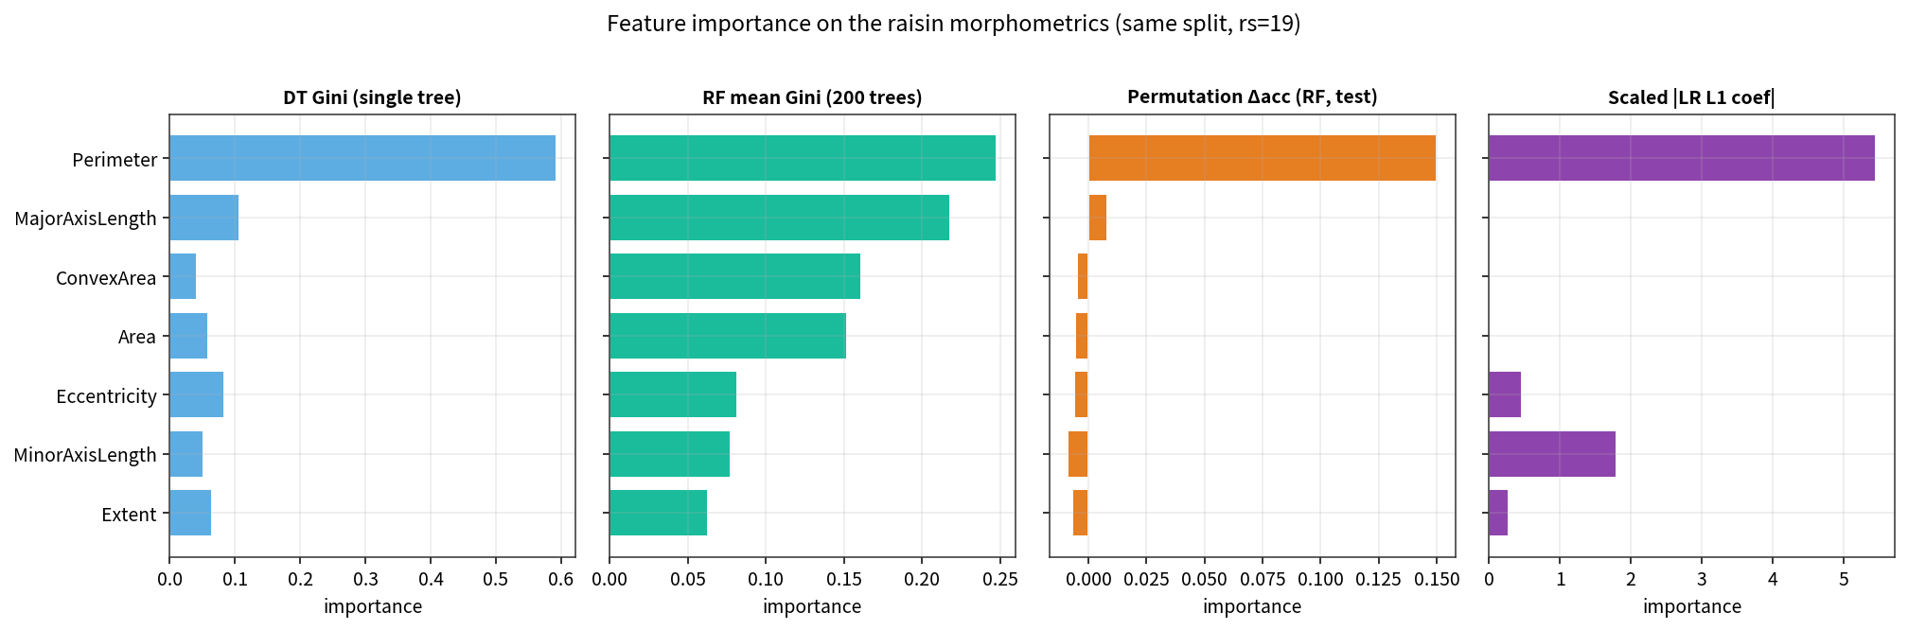

Key Takeaways
- Hyperparameters (depth, C, penalty) are chosen; coefficients and split thresholds are learned.
- GridSearchCV exhausts a list; RandomizedSearchCV draws n_iter times from distributions. Same attributes after fit.
- best_score_ selected the setting. Generalisation is score(X_test, y_test). Do not quote CV as the headline.
- Gini on one tree is cheap and correlation-blind. Confirm with a forest and a permutation drop.
- On this card a 3×3 grid already saturates. Raising n_iter from 4 to 32 did not lift hold-out accuracy. Tiny n and label flips did.
- Not a packing-line spec. Teaching card only.

